Science



Electricity

**Computing**

E-Safety

Microsoft Publisher

**Website links**



<https://www.bbc.co.uk/bitesize/topics/zwmpfg8>

<http://www.primaryhomeworkhelp.co.uk/Romans.html>

<https://www.youtube.com/watch?v=D-VmbxpEFAA>

**Spanish**

* My Family
* Months
* Days of the week



**RE**

Islam



**Maths**

* Multiplication
* Division
* Money
* Maths games
* Problem solving
* Reasoning

**English**

* Celtic Britain fact-file
* Romulus and Remus
* Letter from Roman Soldier
* Speech from Boudicca
* Describe a Roman God
* Reading 

**History**

* Celtic and Roman Britain

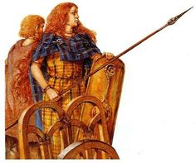

**Romans in Britain**

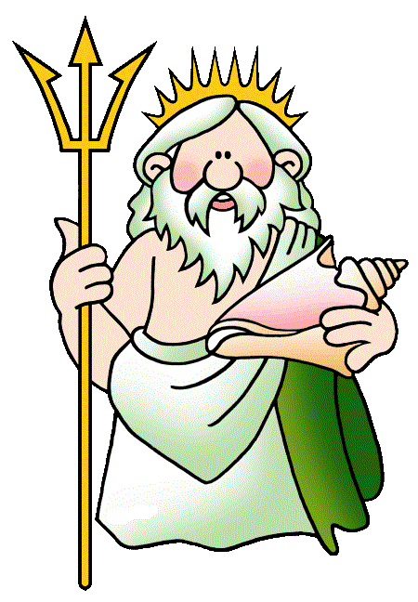

**Geography**

* Europe and the Roman Empire



**Planning for The Creative Curriculum: Year 3 Spring Term 2020**

**Art/DT**

Mosaics

Design and make Roman Armour



**PE**

* Gymnastics
* Ball Skills



**PSHCE**

Settling into year 3

School Rules

New timetable