**Congratulations on achieving Europe.**

Learning number bonds to 10…

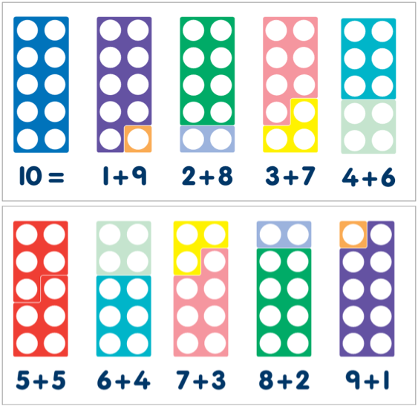

Count in 2’s…

Play memory games where you turn the card to find a matching pair. Count the pairs at the end of the game. 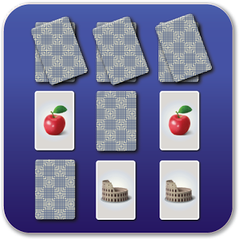

**You are moving on to Asia.**

|  |  |
| --- | --- |
|  | Count forwards and backwards up to 100 and over. |
| Say one less and one more than any given number up to 100. |
| Count in twos, fives and tens. |
| Know by heart all number bonds to 10. |
| Say the doubles of all numbers up to 10. |
| Say the halves of all even numbers up to 20. |
|  |

b

Make your own 100 square. Make deliberate mistakes when counting or chanting numbers. Can your child spot what is wrong?

Play games like snakes and ladders!

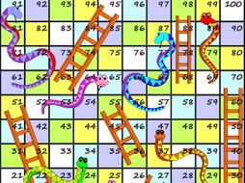

Counting forwards and backwards up to 100…

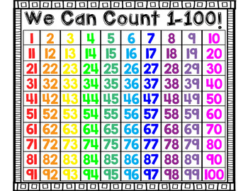

Finding doubles and halves…

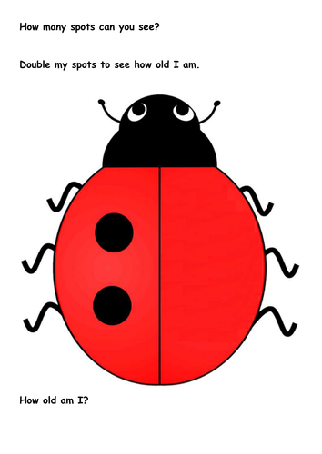

Draw some ladybirds. Play ‘How old am I?’ Double the spots to find out!

Try [www.ictgames.com](http://www.ictgames.com) and play Archery Doubles

Count in 5’s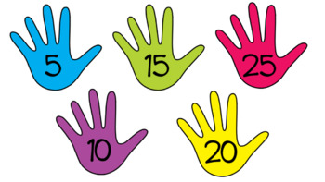Make your own hand print number line by drawing round your hands, then cutting out!

Counting in 10’s…

Make bundles of ten using objects eg straws, then count them. 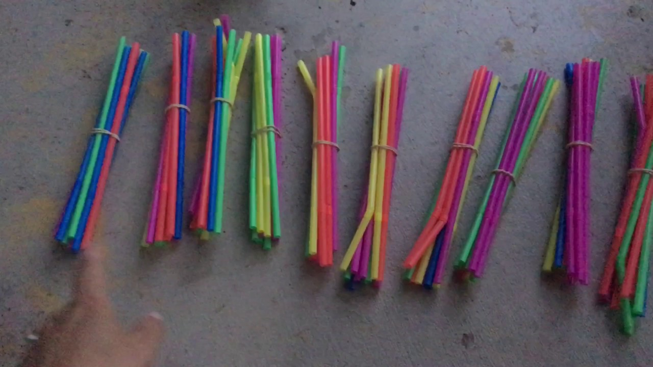

Count in twos: 2 4 6 8 10 12 14 16 18 20

Count in fives:5 10 15 20 25 30 35 40 45 50

Count in tens: 10 20 30 40 50 60 70 80 90 100