**Congratulations on achieving Australasia.**

**Say the number that is 10 more or less…**

Take turns to say a number. How quickly can your partner say 10 less and ten more!

Try: 346 567 450 605

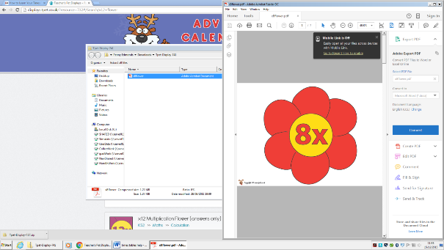**You are moving on to North America.**

Make your own 8x table wheel. Cover up parts of the wheel to check your recall!

|  |  |
| --- | --- |
|  | Count forwards and backwards in multiples of 50 |
| Count forwards and backwards in multiples of 100 |
| Say the number that is 10 more or less than a given number |
| Say the number that is 100 more or less than a given number |
| Know by heart all multiplication facts up to 12 x 4 |
| Know by heart all multiplication facts up to 12 x 8 |

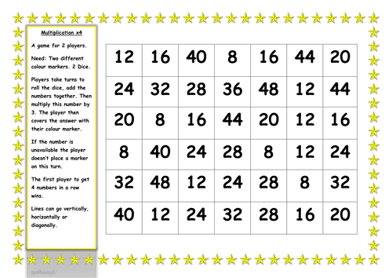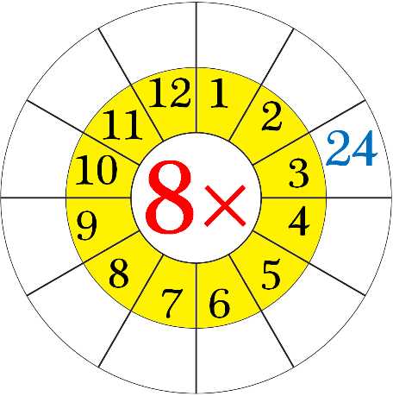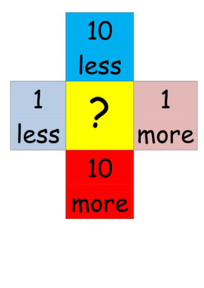

e

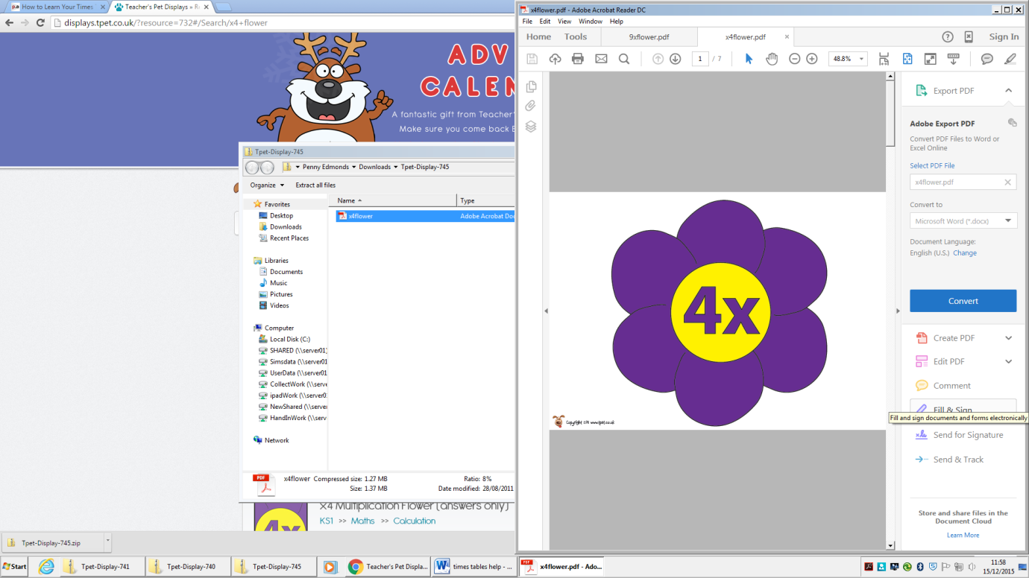

Play 4x tables game. Make some 4 x tables

question cards and a target board. Cover

the answer with a counter. First to cover

their board wins.

**Say the number that is 100 more or less…**

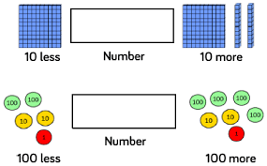

**Counting forwards and backwards in 50’s and 100’s…**

**50 - 100 – 150 – 200 – 250 – 300 – 350 – 400 – 450 – 500**

**100 – 200 – 300 – 400 – 500 – 600 – 700 – 800 – 900 - 1000**