**Congratulations on achieving South America.**

**You are moving on to Antarctica.**

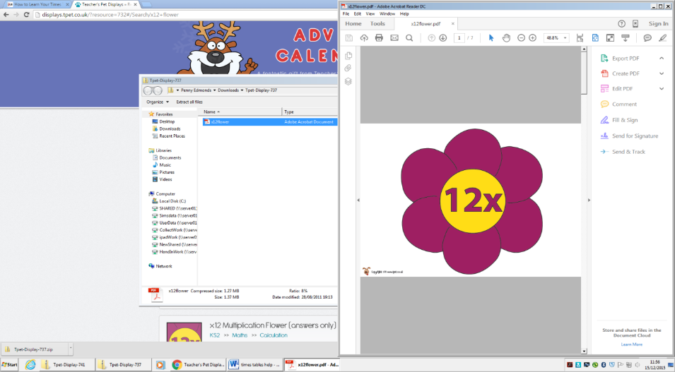**You amoving on to Antarctica.**

|  |  |
| --- | --- |
|  | Count forwards and backwards in multiples of 25 |
| Count forwards and backwards in multiples of 1000 |
| Count forward and backwards in hundredths |
| Say the number that is 1000 more or less than a given number. |
| Count forwards and backwards in 7’s |
| Count forwards and backwards in 12’s |
| Know by heart the multiplication facts for 12 x 7 |
| Know by heart the multiplication facts for 12 x 12 |

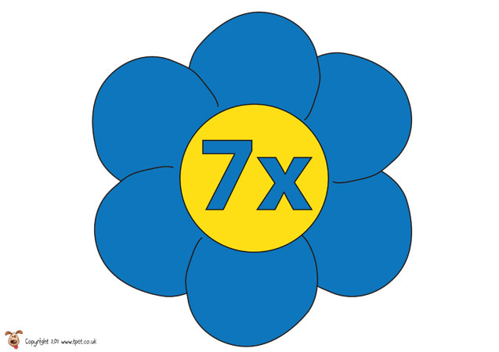

Make a target board. Take turns to call out 7x tables questions. Cover the answer with a counter.

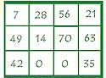

The simple rule that you can apply to all of the 12’s is to partition the calculation into 10 x and 2 x then add the answers together.

 1 X 12 = 12 (1 X 10 and add 2)

2 X 12 = 24 (2 X 10 and add 4)

3 X 12 = 36 (3 X 10 and add 6)

4 X 12 = 48 (4 X 10 and add 8)

5 X 12 = 60 (5 X 10 and add 10)

6 X 12 = 72 (6 X 10 and add 12)

7 X 12 = 84 (7 X 10 and add 14)

8 X 12 = 96 (8 X 10 and add 16)

9 X 12 = 108 (9 X 10 and add 18)

10 X 12 = 120 (10 X 10 and add 20)

11 X 12 = 132 (11 X 10 and add 22)

12 X 12 = 144(12 X 10 and add 24)

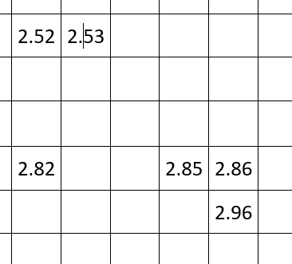

**Counting forwards and backwards in multiples of 25 and 1000…**

**25 - 50 – 75 – 100 – 125 – 150 – 175 – 200 – 225 – 250 – 275 – 300**

**1000 – 2000 – 3000 – 4000 – 5000 – 6000 – 7000 – 8000 – 9000 – 10,000**

g

**Say a number 1000 more or less than a given number…**

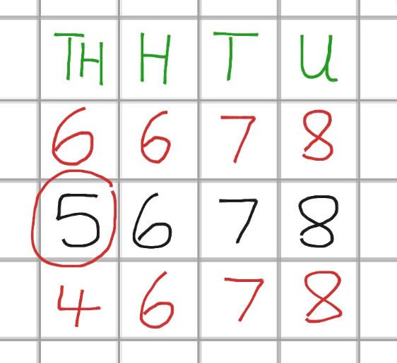

**Count forwards and backwards**

**in hundredths…**

Play ‘4-in-a-Row’;

Take turns with your partner to

fill in a box on the sheet.

The first person to get

4 correct answers in a row wins.