**Congratulations on achieving Antarctica.**

**Use number bonds up to 20 to mentally add and subtract multiples of 10 and 100.**

How many part whole models can you draw for 200 or 2000 using your knowledge of number bonds to 20?

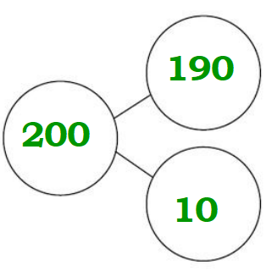

Can you create 2 additions and 2 subtractions to make these target numbers:

190 240

220 160

170 150

Example:

140 – 20 = 120

190 – 70 = 120

90 + 30 = 120

50 + 70 = 120

**Round any number to the nearest 10, 100 and 1000.**

Roll a dice to make a 4-digit number. Now round it to the nearest 10, 100 and 1000.

**You are now a Globetrotter.**

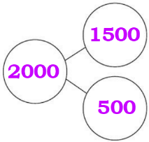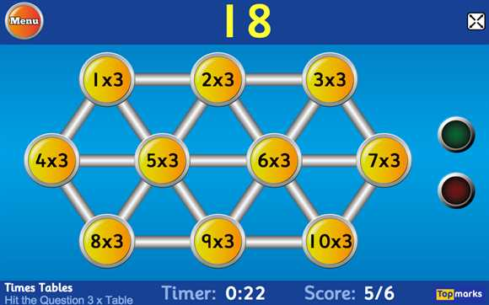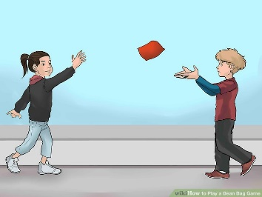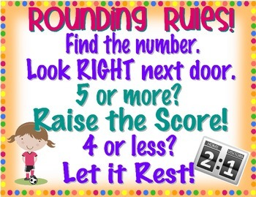

h

**Play ‘Hit the Button’**

**on an iPad.**

**Make your own loop cards to share with your class.**

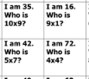

**Draw triangles for your chosen division facts…**

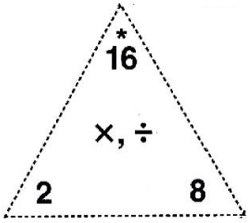

**A game for 3 or more players:**

* Pick someone to be the thrower of the ball or bean bag. Everyone else is a catcher.
* The thrower throws the ball to a catcher of their choice and shouts out a multiple of the times table being practised. Can they respond with the times table before they catch the ball? Throw it back to the thrower then pick someone else.

**Example for the 7 times table:**

**Thrower: 49,**

**Catcher 1: 7,**

**Thrower: 35,**

**Catcher 5…**

**Revise all division facts…**

|  |  |
| --- | --- |
|  | Revise all division facts for the 2, 5 and 10 times tables. |
| Revise all division facts for the 3, 4 and 8 times tables. |
| Revise all division facts for the 6, 9 and 11 times tables. |
| Revise all division facts for the 7 and 12 times tables. |
| Round any number to the nearest 10, 100 and 1000. |
| Use number bonds up to 20 to mentally add multiples of 10 and 100. |
| Use number bonds up to 20 to mentally subtract multiples of 10 and 100. |