**Congratulations on achieving your Globetrotter passport.**

**Say all square numbers up to 12 squared.**

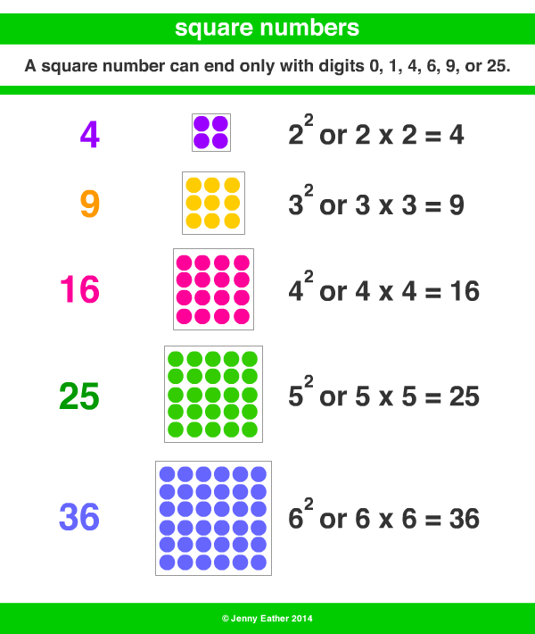

Square Pairs Game

Copy the game board onto your whiteboard:

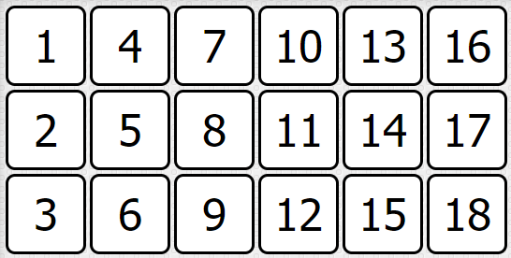

Take it in turns with a partner to select two numbers that add up to a square number.

**Count forwards and backwards in powers of 10 up to 1,000,000.**

Pick a starting number and challenge a friend to count forwards or backwards in powers of 10.

*‘Count backwards in 1000s from 23,000.’*

Throw and catch a ball between you and see how far you can count. **CHALLENGE: Shout forwards/backwards or change the power of 10 you are counting in.**

**You are moving on to Mars.**

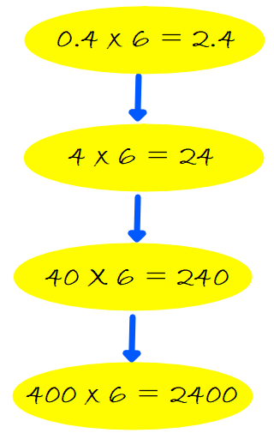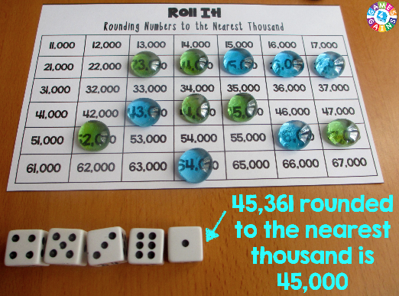

i

**Use times table facts to multiply pairs of multiples**

**of 10 and 100.**

Create a

chain of facts

that you can

derive from

a times table

fact that you

know.

How long can you make it?

**Say all prime numbers up to 19.**

A prime number is a whole number greater than 1 whose only factors are 1 and itself. **The first few prime numbers are 2, 3, 5, 7, 11, 13, 17, 19.**

Deal the cards and flip them over. When you get a prime number, call out

‘Prime’!

**Round any number to the nearest 10,000 and 100,000.**

Roll it, Round it:

You will need:

* 5 or 6 dice
* A game board

counting in

10,000s or 100,000s. You can make your own.

* Different colour counters for each player.

Roll the dice and place your colour counter on your number rounded to the nearest 10,000 or 100,000. First to 4 in a row wins!

|  |  |
| --- | --- |
|  | Counting forwards and backwards in powers of 10 up to 1,000,000. |
| Use times table facts to multiply pairs of multiples of 10 and 100. |
| Round any number to the nearest 10,000 and 100,000. |
| Say all prime numbers up to 19. |
| Say all square numbers up to 12 squared. |