Congratulations on achieving Mars.
Round any decimal to the nearest whole, tenth and hundredth.
1) Roll a die three times and use it to make as many decimals as you can. E.g. 5, 1 and 3 could make 1.53. Now round all of the numbers you have made to the nearest tenth or whole.
2) Visit Topmarks.co.uk and use the rounding dartboard.

List the factor pairs of any number up to 100.

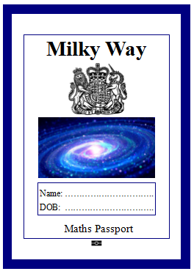 | Round any decimal to the nearest whole, tenth and hundredth.
 | List the factor pairs of any number up to 100.
 | Say all prime numbers up to 50.
 | Say the square root of numbers up to 144.
 | Add large numbers mentally.
 | Subtract large numbers mentally.
 | Know common equivalent fractions, decimals and percentages.
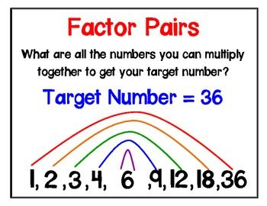
You are moving on to the Milky Way.
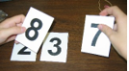
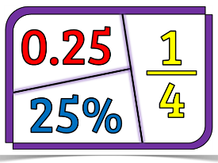
j
574 – 199 rounding and adjusting
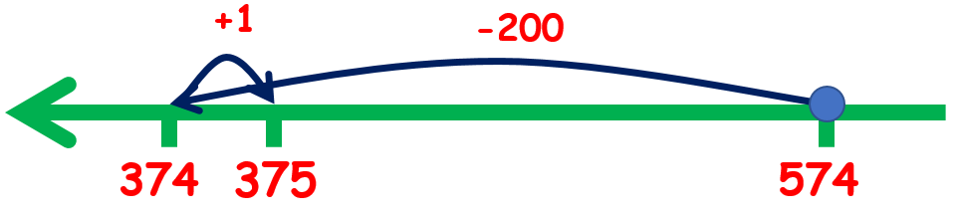

12462
– 2300
10162
use your place value knowledge

666 – 361 count on
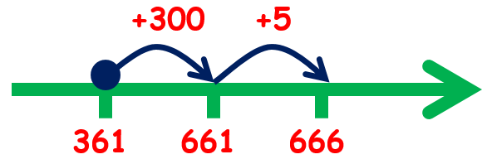

6006 – 5983 find the difference by targeting multiples of 10
7 more is 5990
10 more is 6000
6 more is 6006

251 + 248
1 more than 250 + 2 less than 250
500 + 1 – 2 = 499
add near doubles by adjusting
Know common equivalent fractions, decimals and percentages.
Make jigsaw pieces for the FDP facts you want to remember. Shuffle the pieces.
Can you put
them back
together?

Add and subtract large numbers mentally. Make some calculations with digit cards. Can you use a mental method to solve them?
Examples:
Say the square root of numbers up to 144.
