**Congratulations on achieving the Milky Way.**

**You are moving on to the Universe!**

**Say all prime numbers up to 100.**

Prime numbers only have two factors – 1 and themselves!

**Convert mixed to improper fractions and visa versa.**

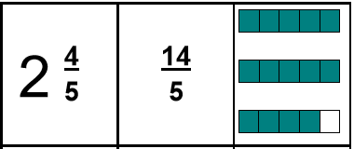

|  |  |
| --- | --- |
|  | Say all cubed numbers up to 12 cubed. |
| Say all prime numbers up to 100. |
| Know tricky equivalent fractions, decimals and percentages. |
| Know divisibility rules for 3, 4 and 6. |
| Know divisibility rules for 8, 9 and 12. |
| Know divisibility rules for 7 and 11. |
| Know conversions for metric and imperial measures. |
| Convert mixed to improper fractions and visa versa. |

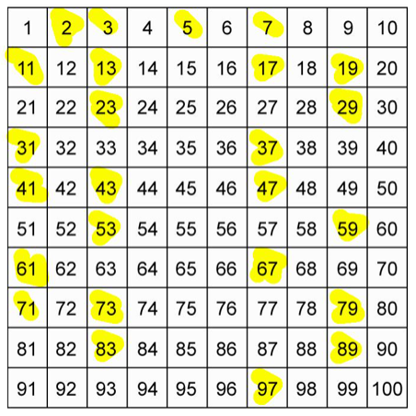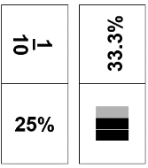

k

**Say all cubed numbers up to 12 cubed.**

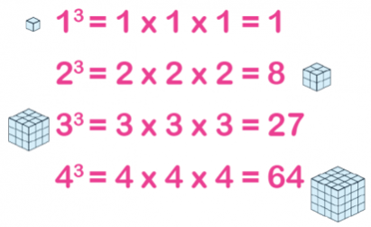

**Know conversions for metric and imperial measures.**

Could you make up some conversion word problems for someone else working on the Universe passport.

**Know divisibility rules…**

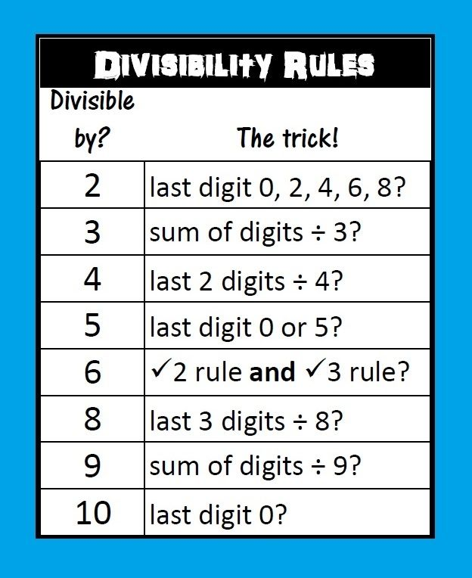You could design a poster to help you remember the rules. Don’t forget to include some examples.

**Know tricky equivalent fractions, decimals and percentages.**

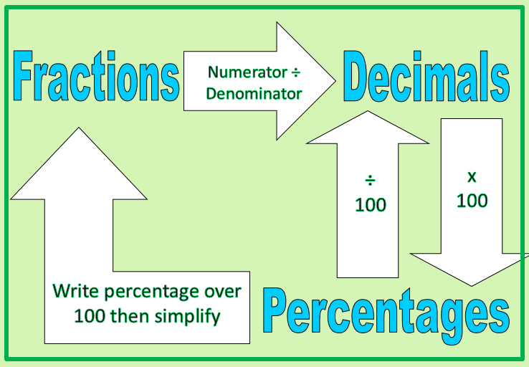You could make a set of dominoes to help you practise.